Instructions for changing one’s password in azure for the NTIA SM domain

Changing password:
One must know their current password to change it. If the current password is unknown, then contact servicedesk@ntia.gov to get a temporary password set on the account. The service desk will supply the user with the new temporary password for accessing the password reset function.

Password reset:
- Log into https://myaccount.microsoft.com using your SM user account and password. SM user accounts are fully qualified. Ex: user@sm.ntia.doc.gov
- Choose the “Security info” selection for changing your password
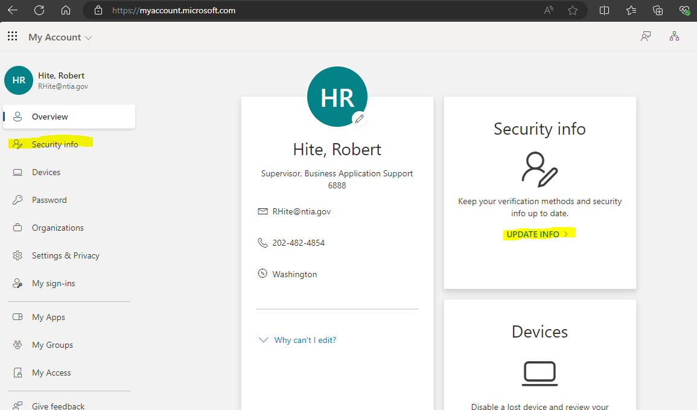

- Select “change” on the password row
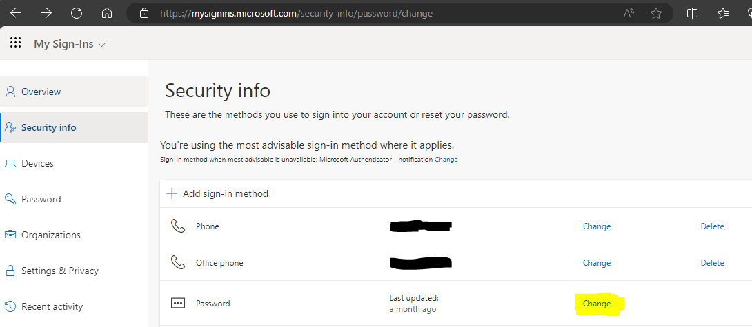
- Update the password. Note that passwords for this domain must have at a minimum: 2 uppercase characters, 2 lower case characters, 2 numbers, and 2 special characters. Passwords must be at least 12 characters in length.
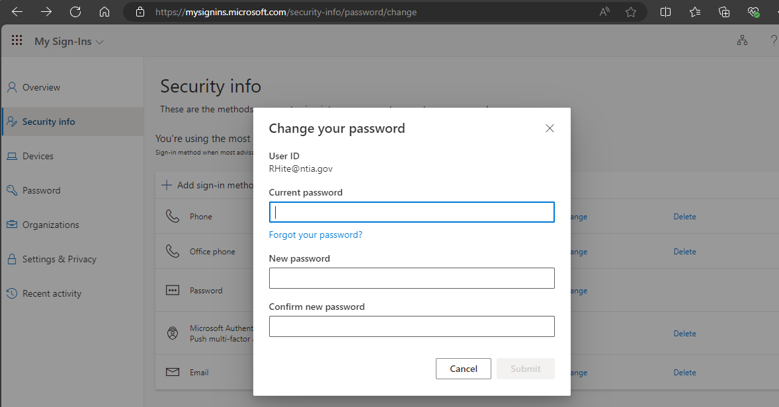

You may now use the new password for logging into NTIA systems that you are authorized for.

